A list of group members involved in the process of making the application.

Darius

Luke

Hayden

Savannah

Caitlin

Zixun Yu

The artefact. Although this isn’t graded directly, it is useful to see the application that is a result of the SE processes which are graded in this assignment.   
The artefact below provides a GUI form application using C# as our programming language to allow the user to generate news articles when pressing the “Get News”, displaying them in the table and showing the track corresponding with the news article using the API keys for both Spotify and the news.

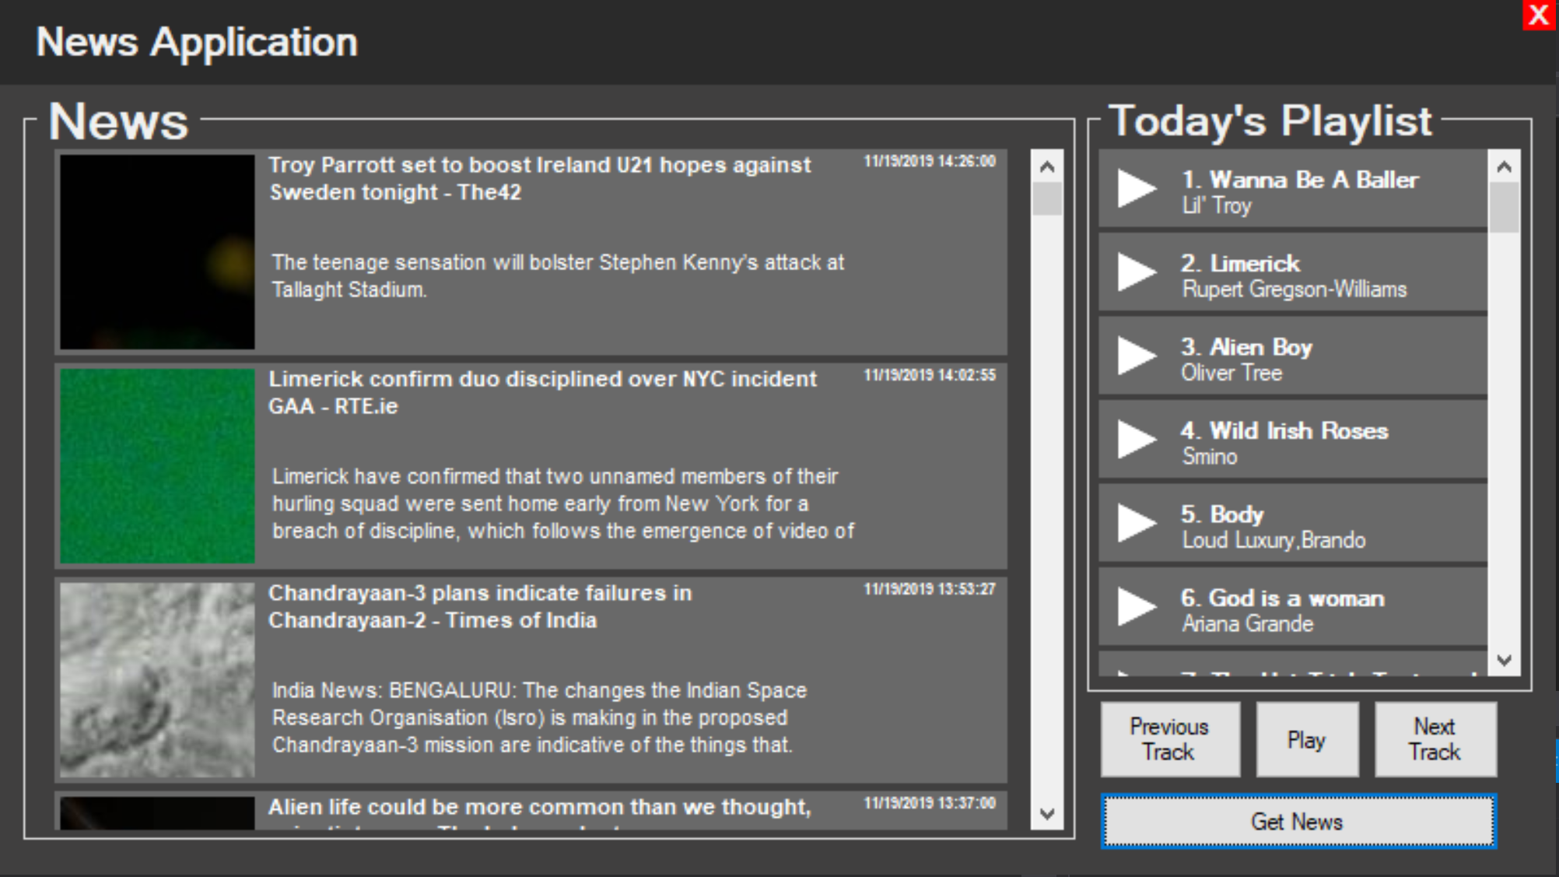

**Sprint 1: Made the User Interface**

For the first sprint, I had to think on the design and interaction when dealing with the user interface such as whether the user has experience when interacting with the application, so I had to make it plain and simple for different users who have trouble experiencing complex applications such as the News applications.

**Sprint 2: Found API keys for Spotify and the news**

Once completing the first sprint, I had to find API keys for both Spotify and the news by looking online and searching for them. When finding the API keys, I had to test them to make sure that when I generate the news it will display todays article and that it works with the artefact in C#. In the end, I managed to find the API key that worked updated to today’s and worked with C#.

**Sprint 3: Made application be able to query Spotify results**

For sprint 3, I then coded the application to be able to query Spotify results with the API key. For this to work, I needed to add the buttons, text and panels for the news and Spotify then structure them in the news application before coding everything. This part of the process was covered in sprint 1 when making the user interface. Knowing that the API works, it took 3 weeks to produce to make the application run news article with the help of the API key.

**Sprint 4: Made a word extractor to extract words from headlines**

For sprint 4, we have created a function that will extract unimportant words from the news headlines when users

**Sprint 5: Make the playlist show up**

**Sprint 6: Make music play**

**My contribution to the project**

What I did in my group is program the artefact. When programming the artefact, I had to first plan exactly what I need to include in my artefact such as the design part how it should look like proving a black text on white background or providing white text on black background. I also need to make sure that it’s easy and efficient when the user interacts with it, but I also had to think of how to develop and maintain the artefact before starting on it.

The best way to describe the structure of a system such as attributes, methods and the connection of the objects for each class so I created a class diagram to make it easier to understand the structure of the application.

I created a Product backlog explaining the tasks that each person did or whether we have completed it.

The main roles were to program the artefact, create a diagram for the structure of the application and doing the product backlog.

**Programming Logs**

I created pair programming logs for Zixun Yu and Myself. I was the driver, working on the programming side of creating the artefact and Zixun Yu was the observer, checking for any errors or mistakes that I might have made while programming then for 10 minutes we swapped round making me the observer and Zixun Yu the driver. The Tables below shows two tables explaining information like the number of errors spotted in the code, what errors they have and the solutions to that problem.

**Pair Programming Log:**

**Driver:** Darius

**Observer**: Zixun

**Sprint 2 task:** News API

|  |  |  |  |  |  |
| --- | --- | --- | --- | --- | --- |
| Date &Time session started | Number of lines of code written | Errors spotted (and by whom) | Activity (what’s being coded), or tested, or compiled | Comments | Fixed code |
| 19th November 2019  13:00 – 15:00 | 1 line | 1 | SearchNewsURL = "https://newsapi.org/v2/top-headlines?country=ie&apiKey="; | Need to add the public String SearchNewsURL = "https://newsapi.org/v2/top-headlines?country=ie&apiKey="; to access the Spotify API. | Yes |
| 19th November 2019  13:00 -15:00 | 8 lines | 2 | string Title = Item.title;  string Author = Item.author;  string Desc = Item.description;  string Img = Item.urlToImage;  string Pub = Item.publishedAt;  ___________________________________ NewsPanel Stuff = new NewsPanel(Title, Author, Desc, Img, Pub, Articles, panel2); | The error was not showing the information about today’s articles. After Implemented the Spotify API, you need identify the key bits of information of the News articles such as title, author, description, urlToImage, published. _____________________________  Place the information in the panel to display the information from the News API | Yes     Yes |
| 19th November 2019  13:00 -15:00 | N/A | 0 | Displays today’s news articles | N/A | N/A |

**Pair Programming Log:**

**Driver:** Zixun

**Observer**: Darius

**Sprint 3 task:** Made our application be able to query Spotify results

|  |  |  |  |
| --- | --- | --- | --- |
| Date &Time session started | Number of lines of code written | Errors spotted (and by whom) | Activity (what’s being coded), or tested, or compiled |

|  |  |  |  |  |  |
| --- | --- | --- | --- | --- | --- |
| Date &Time session started | Number of lines of code written | Errors spotted (and by whom) | Activity (what’s being coded), or tested, or compiled | Comments | Fixed code |
| 19th November 2019 | 41 | 1 | Choose the function |  | Yes |
| 19th November 2019 | 58 | 3 | Update playlist |  | Yes |

**Burndown Chart**

**Critical Reflection**  
By using SCRUM for the development of the artefact it allowed us to plan exactly how to carry out the project with effectively and efficiency. The SCRUM framework structures all the components such as the roles, activities and artefacts needed to manage the work for the artefact.

**SCRUM Team**

Product owner

Savannah/Caitlyn was responsible for the end results for the development of the artefact and how it’s carried out in the end. Luke was also responsible for the functionality and features for the News application. (The Scrum Guide, 2017; Lecture 4, 2019)

ScrumMaster

Hayden was the leader of the group, guiding and directing the team in creating and following our own process based on the framework. During the difficulties and problems faced when creating the artefact, Hayden help provide solutions to these issues and it allowed us to continue. (The Scrum Guide, 2017; Lecture 4, 2019)

Development team

Our development team was the entire group. We had Luke as Lead Developer. Me and Hayden as the programmers, Savannah and Caitlin testing the artefact to making sure it worked as it should be and Zixun Yu created the user experience design for GUI application for our sprint 1. (The Scrum Guide, 2017; Lecture 4, 2019)

**Activities in the Scrum practice**

**Sprints**

By simply labelling each sprint from 1 to 6 and putting the start and end date for each sprint we were able to plan each step on what we needed to create our application. (The Scrum Guide, 2017; Lecture 4, 2019)

**Sprint planning**  
When planning the sprint, we needed Luke and the rest of our group to agree on what the sprint is supposed to achieve. The best way to approach this with assurance that it will be complete the features forms the second backlog called the sprint backlog which is one of the artefacts in the SCRUM framework. (The Scrum Guide, 2017; Lecture 4, 2019)

**Daily scrum**

As a user, I needed to select a button that generates news articles corresponding with the Spotify track. To do that I had to start coding to allow the button to generate the news with the Spotify track. While coding the GUI application I experienced some obstacles when testing it this prevented me from progressing, so I had to go back to my first daily scrum to continue with the next daily scrum. In the end, I managed to figure out the problem and was able to continue coding. (The Scrum Guide, 2017; Lecture 4, 2019)

**Sprint execution**

**Sprint review**

In the middle of creating our application we were able to display all the features on the GUI application and design the layout of the application with some code, but we still had a lot functionality to implement in the buttons and label text boxes that display the articles. (The Scrum Guide, 2017; Lecture 4, 2019)

**Sprint retrospective**

After doing the sprint review, we had to check whether what we did so far worked the way it should do or what didn’t work or what needed changing. (The Scrum Guide, 2017; Lecture 4, 2019)

**Product backlog grooming**

When using SCRUM as the process for our artefact we found it very useful and simple to use because it provided specific instructions on how to carry out the artefact such as structure our work and assigning each team member a task. Contrarily, using the Agile Process uses principles that generate a sequence that repeats itself till it reaches the end solution for our application. (The Scrum Guide, 2017; Lecture 4, 2019)

c. This critical evaluation should include both the advantages and disadvantages of the SCRUM methodology. You should pay particular attention to how SCRUM differs in terms of implementing the methodology compared to others such as Waterfall, DSDM, Spiral, etc.

5. Open Source and SCRUM tools   
a. An evaluation of tools used to facilitate the development of an open source project using SCRUM b. What tools were used, how did you use them?   
c. What were the advantages and disadvantages of these? [source1;source2;]

**Group evaluation**

|  |  |
| --- | --- |
| **Names** | **Average Contribution** |
| Darius | 100% |
| Luke | 100% |
| Hayden | 100% |
| Savannah | 100% |
| Caitlin | 100% |
| Zixun Yu | 100% |

**References**

Lecture 4(2019)lec-4 SCRUM [accessed 17 November 2019]

The Scrum Guide(2017)The Definitive Guide to Scrum. The Rules of the Game. Available from https://www.scrumguides.org/docs/scrumguide/v2017/2017-Scrum-Guide-US.pdf#zoom=100[accessed 26 November 2019]

Spotify Developer(2019) Web API.Spotify. Available from https://developer.spotify.com/documentation/web-api/ [accessed 26 November 2019]